**TITLE OF FULL PAPER**

**Firstname Surname (1st author) & Firstname Surname (2nd author) – 12 points and Bold**

Affiliation (Department of Taxation, Federal Polytechnic, Ilaro, Ogun state, Nigeria) – 11 points

First.Author@.edu.ng; [Second.Author@.edu.ng](mailto:Second.Author@.edu.ng) – 11 points

**ABSTRACT**

Abstract should be Times New Roman. Font size 11 points and Single spacing.

An Abstract should not be more than 250 words.

**KEYWORDS:**  This should not be less than 3 and not more than 6 keywords

# Introduction

Introduction and the entire body of the text should be Times New Roman, Font size of 11 points and 1.15 spacing.

Papers should clearly describe the background of the subject. It is recommended that the Literature Review should be discussed here in brief because this Conference does not support long literature review or Literature Review as a section except the paper is a review work. Empirical studies are mostly preferred. Review papers must be thoroughly packed to be accepted.

It is expected that authors will submit carefully written and proofread work. Careful checking for spelling and grammatical errors should be performed.

The number of pages of the paper should be between 6 minimum and 12 maximum.

# Methodology

This part should discuss methods used in carrying out the work.

Technical terms should be explained unless they may be considered to be known to the conference community.

Spaces should be used to separate paragraphs.

Conclusions/Recommendations should state concisely the most important propositions of the paper as well as the author’s views of the practical implications of the results.

## Sub-section 1

Use subsection this way if there is need for such

## Sub-section 2

Use subsection this way if there is need for such

## Tables and Figures

Figure captions and table headings should be sufficient to explain the figure or table without needing to refer to the text. Figures and tables not cited in the text should not be presented. The following is an example for Table 1.

Table 1: Title of the Table

|  |  |  |
| --- | --- | --- |
| **Year** | **Total No of Applicants** | **Total No of Admitted Students** |
| 2019 | 4700 | 2500 |
| 2020 | 3500 | 2800 |
| 2021 | 4200 | 3100 |
| 2022 | 7300 | 3500 |

Tables and figures should be placed close after their first reference in the text. All figures and tables should be numbered with Arabic numerals. Table headings should be centered above the tables. Figure captions should be centered below the figures as shown in Figure 1. The source of all tables and figures must be properly stated below the tables and figures.

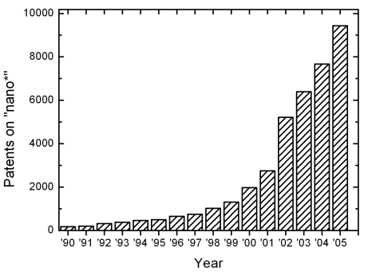

Fig. 1: Number of patents on nanotechnology with time

## Equations

Each equation should be presented on a separate line from the text with a blank space above and below. Equations should be clear, develop using Equation Editor and expressions used should be explained in the text. The equations should be numbered consecutively at the outer right margin, as shown in Eqs. (1) - (3) below. Here is one example.

In this case, the governing system of equations can be written as follows:

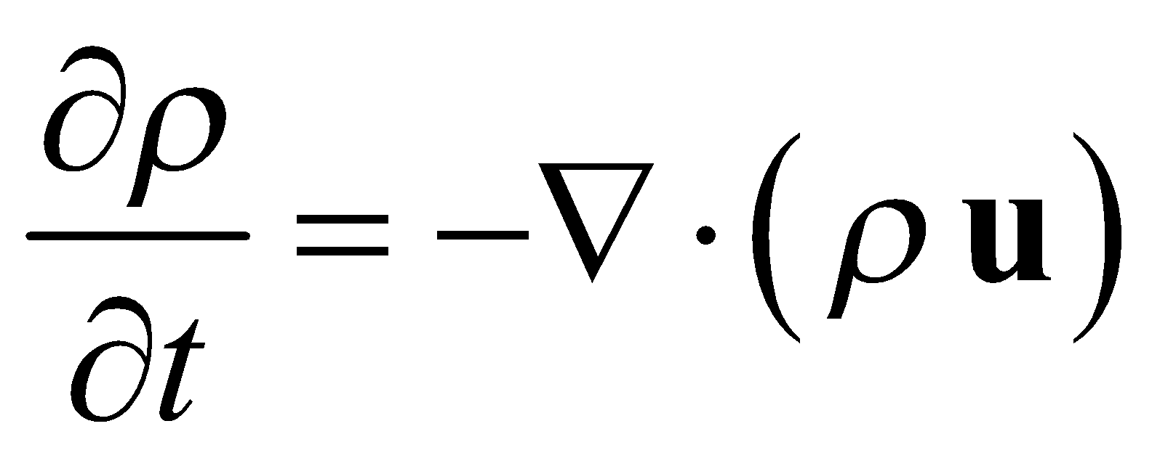 (1)

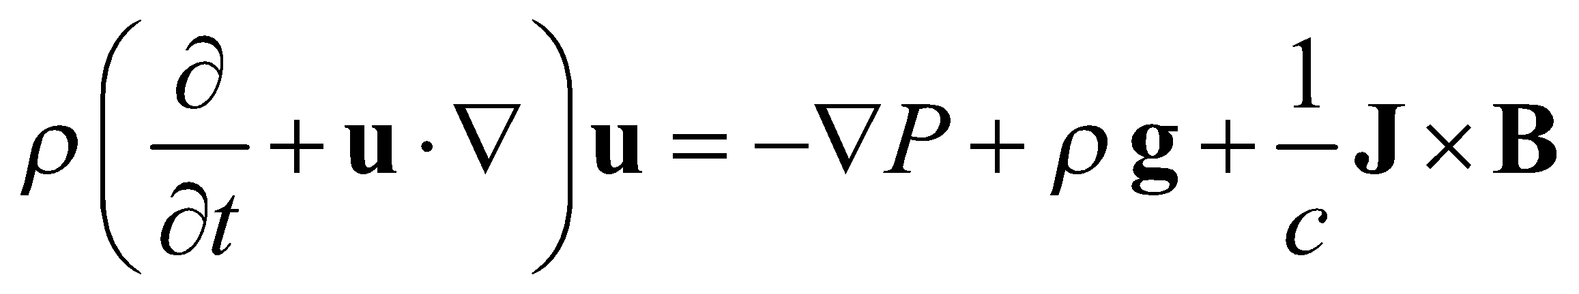 (2)

## 3. RESULTS

The result from the work is placed here with short description.

## 4. DISCUSSION

Comprehension discussion of results and implications are done here. Also, the contribution to knowledge should be done here

## 5. CONCLUSION

Conclusion should state concisely the most important propositions of the paper as well as the author’s view of the practical implications of the results.

**REFERENCES**

**Journals**

Storey, J. D. (2002). A direct approach to false discovery rates, *Journal of the Royal Statistical Society*, **64**(3),479–498

Jun, S., Rho, S., & Hwang, E. (2010). Music retrieval and recommendation scheme based on varying mood sequences. *International Journal on Semantic Web and Information Systems (IJSWIS)*, **6(2)**,1-16

**Books**

James, G., Witten, D., Hastie, T. & Tibshirani, R. (2013). *An introduction to statistical learning with application in R.* New York: Springer.

Hajez, H. & Karaman, R. (2015). *Drug Overview in Commonly Used Drugs*. Nova: Nova Science publisher

**Chapter Contribution in a Book**

Hoskins, S. P., Shyr, D., & Shyr, Y. (2017). Sample Size Calculation for Differential Expression Analysis of RNA-Seq Data. In *Frontiers of Biostatistical Methods and Applications in Clinical Oncology* (pp. 359-379), Springer, Singapore

**Conference Proceedings**

Andersen, R., Gleich, D.F., & Mirrokni, V. (2012). Overlapping clusters for distributed computation. In *Proceedings of the fifth ACM international conference on Web search and data mining* (pp. 273-282).

**Web Reference**

NIH. (2015, December 10). National Institutes of Health. Retrieved 5 July 2009 from: <http://www.nih.gov/>.